網站

Here are some helpful UX design resources to keep in mind as you learn. You might even want to bookmark some of these websites on your computer to review on an ongoing basis!

* [Interaction Design Foundation](https://www.interaction-design.org/literature): A library of open-source UX design resources, including new articles published every day. There are also local [meet-ups](https://www.interaction-design.org/events/ux-meetups) (virtual and in-person) that are free to attend and open to everyone.
* [Adobe XD Ideas](https://xd.adobe.com/ideas/?sdid=61PM7WSH&mv=social&mv2=ownsoc-org): A blog curated for entry-level UX designers. You’ll find inspiring examples of great design, valuable career tips, and more.
* [UX Collective on Medium](https://uxdesign.cc/): An article platform with stories on user experience, visual design, product design, and more. Articles on Medium are written by a large variety of writers and cover a range of topics.
* [Nielsen Norman Group](https://www.nngroup.com/articles/): Research-based UX guidance, including a ton of helpful articles about the design process, research methods, and user testing, which you'll learn about later in the certificate program.

UX 4要素

For a user to have a good experience, the product needs to be usable, equitable, enjoyable, and useful.

Usability refers to the product working well and being easy to use, while usefulness refers directly to the ability to solve user problems.

UX 核心能力和職位分類

Empathy

The ability to understand someone else’s feelings or thoughts in a situation.

There are many different kinds of UX designers: interaction designers, visual designers, and motion designers.

* interaction designers: focus on designing the experience of a product and how it functions
* visual designers: focus on how a product or technology looks
* motion designers: think about what it feels like for a user to move through a product and how to create smooth transitions between pages on an app or a website.

Graphic designers VS UX designers

Graphic designers usually work on the appearance of a physical product, like an invitation or a poster, while UX designers focus on how users interact with the product.

UX團隊：

* UX researchers conduct the studies or interviews that help us learn how people use a product.
* UX writers think about how to make the language within a product clearer to make the user experience more intuitive. This could include writing labels for buttons or adjusting the tone to be formal or friendly.
* Production designers often act as a bridge between interaction designers and engineers. They make sure the first and final designs match in the finished product materials and that the assets are ready to be handed off to the engineering team. The assets are everything from text and images to the design specifications, like font style, color, size, and spacing.
* UX engineers translate the design's intent into a functioning experience, like a website or an app.
* UX program managers ensure clear and timely communication so that the process of building a useful product moves smoothly from start to finish. This might include setting up goals and writing project plans.

The product development life cycle

There are five stages in the product development lifecycle: **brainstorm**, **define**, **design**, **test**, and **launch**

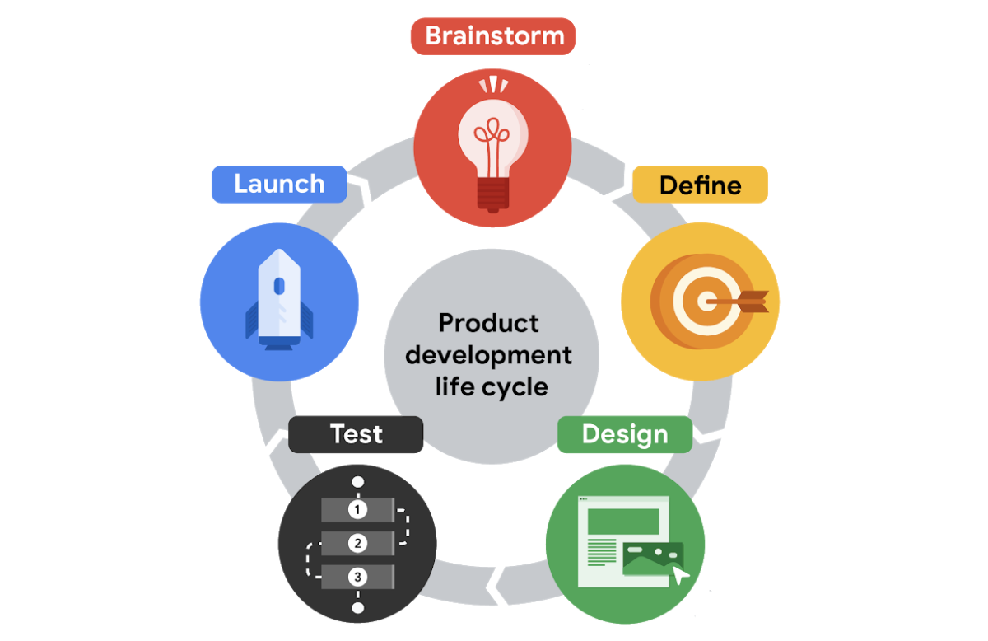

* first stage: brainstorm

active discovery stage

generating ideas about the user and potential needs or challenges the user might have

generates ideas to solve a problem

Research plays a key role in this first stage.

UX researchers and writers are often heavily involved in this stage, where the team might conduct interviews with potential users or conduct other research.

It’s important to pay attention to the diversity of your team at this stage. Teams that have meaningful diversity across identifiers like race, gender, abilities, family structure, age, and ethnicity are generally more effective at brainstorming because they bring together a lot of different lived experiences.

The brainstorm stage is also an ideal time to check out your product's competitors and identify if there are already similar products available in the market. You want your product to fill a gap in the market or solve a problem better than existing products. Completing research into both your competitors and your users helps determine what problems need to be addressed by the product’s design.

* second stage: define

Define is all about using the insights from the brainstorm stage and starting to narrow the focus. During the define stage, the team determines concrete ways that the product being developed will impact the user. As a UX designer, you'll begin to think more about specific details related to the product, who the product is for, what the product will do, and what features need to be included for the product to be successful. Statements that outline the goals or outline any problems you want to answer with the product design are the focus in the define stage.

* third stage: design

In the design stage, UX designers begin to actively develop ideas, and they also check that all specifications from the define stage are realistic. The first two stages are more about preparation and planning. They give you a clear understanding of who the user is, what the user wants, and which problems or challenges you want to address in your design. Using the insights from the first two stages, UX designers generate designs that keep the user top of mind.

You'll create many different assets, including storyboards, which are sketches that help explore the user's experience, or wireframes, which provide outlines of the content layout. Or you might create prototypes, which are models that allow UX designers to test the functionality of a design.

* fourth stage: test

In the test stage, the team evaluates the product design based on feedback from potential users. Testing designs with users is really important because it helps the team focus on the user first and foremost and the designs second. Testing helps identify areas to refine or improve the designs. It also helps UX designers consider the interactivity of the design. This is a stage that involves lots of interaction between UX designers and front-end engineers as they figure out ways to create an end product that satisfies users' needs and is practical and functional. They discuss things like how the color or font can fit the company's brand or whether the prototype designs are easily understandable.

At this stage, the designs go through at least three phases of testing: internal tests within your company, reviews with stakeholders, and external tests with potential users. A stakeholder is a person you need to work with to complete the project or anyone who has some interest in the project, either within or outside of the company.

Running these tests is typically the responsibility of the UX researcher on your team, if you have one.

* First, the team **tests the product internally** to look for technical glitches and usability problems. This is often referred to as alpha testing.
* Then, the product undergoes a **test with stakeholders** to make sure the product is aligned with the company’s vision, meets legal guidelines for accessibility, and follows government regulations for privacy, for example.
* Finally, there’s an **external test with potential users**. This is the time to figure out whether the product provides a good user experience, meaning it’s usable, equitable, enjoyable, and useful. This is often referred to as beta testing.

Gathering and implementing feedback at this stage is absolutely critical. If users are frustrated or confused by your product, UX designers make adjustments or even create new versions of the design. Then, the designs are tested again, until there’s little or no friction between the product and the user.

It’s important to call out that the product development life cycle isn’t a completely linear process. Your team might cycle between designing and testing a few times before you're ready to launch the product!

* fifth state: launch

The last state is to launch or share a finished version of the product with the public.

This might involve listing an app in the Google Play Store or Apple's App Store, making a website go live, or putting a physical product on store shelves. Launching can be very satisfying for you and your team because you have the chance to understand how your designs will be received in the real world.

However, the work on a product isn't quite finished after launch. You may still identify opportunities to improve on the designs or learn even more about the user experience based on feedback. This could involve going back to the design or testing stages and figuring out ways to produce a more enhanced version of the product.

The launch stage is a time to celebrate your work and start promoting the product. Marketing professionals on your team might post about the new product on social media or publish a press release. The customer support team might get ready to help new users learn how the product works.

Program managers also meet with the cross-functional team to reflect on the entire product development life cycle and ask questions like: What worked and what could be improved? Were goals achieved? Were timelines met? Making time for this reflection is super important, since it can help improve the process going forward.

Job responsibilities of entry-level UX designers

* researching
* wireframing
* prototyping
* creating information architecture
* communicating effectively
* research

understand audiences and learn about their backgrounds; demographics, like age and location; motivations; pain points; emotions; and life goals.

* creating wireframes

A wireframe is an outline or a sketch of a product or a screen.

It helps the designer figure out how a page is arranged, where each piece of a product fits in with the others, and how users will likely interact with the product. We can wireframe by drawing on paper or digitally on a computer.

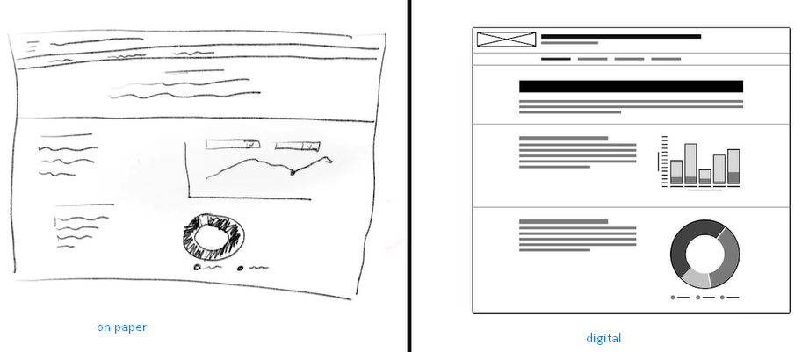

* creating prototypes

A prototype is an early model of a product that demonstrates functionality, like a wireframe, but a lot more advanced. A prototype illustrates a progression from one screen to the next. We can draw our prototypes on paper, create a physical prototype, or build a digital prototype.

* creating the information architecture

The information architecture is the framework of a website, or how it's organized, categorized, and structured. For example, when you click the File menu on a word processing application like Google Docs, you expect certain options, like New or Print, to appear in the dropdown menu. Or when you click on a company's homepage, you expect to find a link to an About page. That structure is the website's information architecture.

* communication

like meetings with colleagues, writing emails, creating proposals, or pitching clients.

Specialists, generalists, and T-shaped designers

* Generalist

A UX designer with a broad number of responsibilities

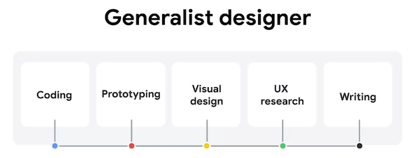

* Specialist

A specialist dives deep into one particular UX design role, like interaction, visual, or motion design

* T-shaped designer

Specializes in one kind of UX design and has a breadth of knowledge in other areas

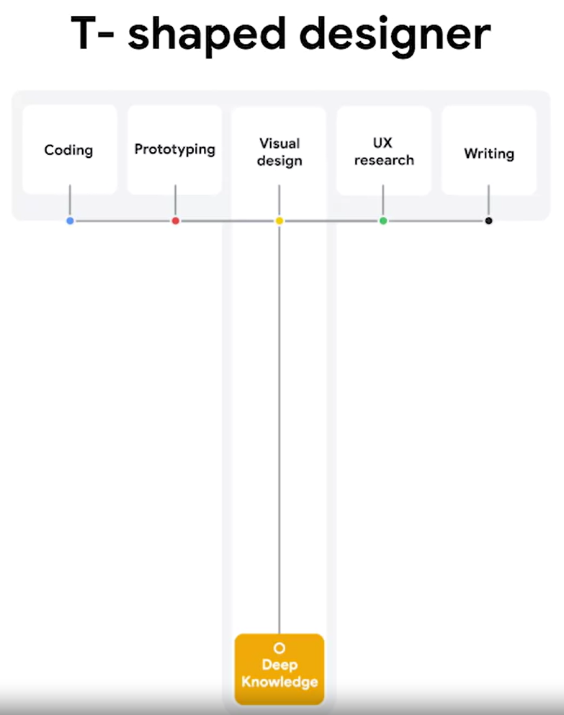

第1分工作來源

Internship

Apprenticeships

Freelancers

Entry-level jobs

UX designer僱主類別

**Startups and small businesses**

**Startups** are new businesses that want to develop a unique product or service and bring it to market. **Small businesses** are privately owned businesses with few employees. A lot of UX designers are excited to start work at startups or small businesses because they can see the impact of their work more quickly and develop a broader range of skills.



* **Team size:** Close-knit team and able to work directly with upper management.
* **Growth:** Opportunity for growth due to taking on many responsibilities (visual design, interaction design, user research, and more).
* **Creativity:** Usually more creative freedom with fewer guidelines and processes.
* **Impact:** Lots of impact on final products, with few people working on a project.



* **Mentorship:** Fewer mentors to choose from within a smaller company.
* **Responsibility:** Most of the responsibility for a UX project falls solely on you, which can be stressful if you have little UX experience.
* **Speed:** Have to be comfortable working quickly and launching work that isn’t perfect, with little oversight.

**Big companies**

At a big company, like Google, you’re likely to work in teams on a specific project. Lots of UX designers want to work at big companies with the people who developed some of the most well-known products in the world. UX teams at larger companies tend to be more compartmentalized by specialization, making it easier for you to become an expert in one particular area of UX.



* **Mentorship**: A variety of experienced designers and other UXers to learn from.
* **Growth**: Lots of opportunity for growth because there are many levels of designers and management.
* **Guidelines**: Clearer guidelines to keep products uniform and on brand.
* **Team size**: More people working on one project, which means you’re better able to focus on your specific responsibilities.
* **Specialization**: Opportunity to focus on one particular area of design.



* **Team size:** May feel less impactful or important as a contributor with lots of other designers on the project.
* **Impact:** May feel small at a company with so many features and products.
* **Guidelines:** Defined guidelines can be restrictive to creativity.

**Design agencies**

A **design agency** is a one-stop-shop for visual brands, products, and services. Working at a design agency can be similar in some ways to working at a small business or startup, except you have multiple companies as your clients. Many agencies tend to work on a broad range of products, so you can explore many kinds of styles and approaches to UX design.



* **Impact:** Lots of impact on projects, if you’re the only UX designer on the team.
* **Networking:** Opportunity to work with senior stakeholders, different teams, and diverse clients.
* **Exposure:** Exposure to lots of companies and industries with different clients.
* **Resume:** Potential to work with large brands and display that work in your portfolio.



* **Mentorship:** Lack of mentorship if you are the only UX designer on a project.
* **Monotony:** Depending on the agency, you could work only on the same type of projects.
* **Ownership:** Might not be able to work on a project from start to finish.
* **Finished product:** Products you work on might not launch, depending on client priorities.

**Advertising agencies**

A lot of UX designers work at **advertising agencies,** which are teams of creatives hired by clients to build marketing campaigns. Sometimes called “creative technologists,” these designers work to create ads for brands using UX principles. This is a great option if you’re open to learning some interesting skills outside of a core UX design role.



* **Autonomy:** Little to no middle management means more autonomy over your work.
* **Learning:** Opportunity to learn about other disciplines, like branding, marketing, and graphic design.
* **Variety:** Every project is different based on the client.
* **Networking:** Work with a bunch of different brands, clients, and teams.



* **Specialization:** Wide variation in projects, so you might not be able to hone in on specific skills easily.
* **Relevance:** Work may often involve branding and marketing, and might not focus on UX design.

**Freelancers**

**Freelancers** are self-employed UX designers who are hired by clients for their independent services. Being a freelancer gives you a lot of freedom, and it’s a great way for new UX designers to gain experience in the field and add work to their portfolio.



* **Schedule:** Set your own hours since you’re self-employed.
* **Flexibility:** Can freelance while working another job or balancing competing priorities.
* **Autonomy:** Choose the work that you want to do.
* **Experience:** Build your portfolio, especially if you don’t have a full-time UX job.



* **Structure:** No one to report to, which means you have to be responsible for getting work done on time.
* **Stability:** Less stable than working for a company or agency, since work is not always guaranteed.
* **Business:** Manage the logistics of your own business, such as filing taxes, billing clients, and more.
* **Mentorship:** Lack of readily available mentors since you’re working by yourself.

**Deciding where to work**

Everyone’s goals as a UX designer are different, so think about what’s most important to you when choosing a place to work. Consider questions like:

* Do you enjoy a lot of structure and processes, or do you like to define your own work and schedule?
* Do you value working on a big team, or are you more comfortable working alone?
* Do you want to focus mainly on UX design, or are you interested in broadening your skill set?

Considering your career goals and how you work best will help you start to figure out the kind of company that might be the best fit for you. Good luck!

Users & User Experience

In the field of user experience design, the “user” comes first.

A user is a person who is trying to **solve a problem** and is looking for a product or service to help them solve it.

The user experience is the journey that the user takes with that product or service.

As a UX designer, your goal is to keep the user at the center of every decision you make, and to do that, you need to get to know your user.

## assistive technology

The term assistive technology, or AT for short, is used to describe any products, equipment, and systems that enhance learning, working, and daily living for people with disabilities.

Assistive technologies include color modification, voice control, screen readers, and alternative text.

* **color modification**

Color modification, like high contrast mode or dark mode on a device, increases the contrast of colors on a screen. Black text on a white background, or white text on a dark background are both examples of high contrast. High contrast makes the interface easier to see for people with low vision.

Color modification also helps anyone who might experience eye strain when viewing screens in the dark or midday, when the sun is creating an intense glare.

* **voice control and switch**

Voice control and switch helps people with limited dexterity and can serve as an alternative to a keyboard or mouse. Voice control allows users to navigate and interact with the buttons and screens on their devices using only their voice.

A switch is an assistive technology device that replaces the need to use a computer keyboard or a mouse. Switch devices can allow users to control technology like a computer or smartphone. There are a lot of different kinds of switch devices, but they all help people with limited motor ability use technology more easily.

* **screen readers**

Next up, screen readers. Screen readers are one of the most common assistive technologies for people with limited vision. The software works on mobile and web devices and reads out loud any on screen text. Screen readers also read any interactive elements, like buttons, along with non visible text, like the button names, and any alternative text for images.

* **alternative text**

Alternative text, or alt text, helps translate a visual user interface into a text-based user interface. It essentially uses words to describe any meaningful image for someone who isn't able to see the image. Alt text is also super helpful for those with low bandwidth connections, too. If your device is unable to maintain a connection to the internet, it may struggle to load a big file or image. Alt text is useful for context when an image fails to load.

Design Thinking: A UX design framework

The Design Thinking framework involves the following phases: empathize, define, ideate, prototype, and test.

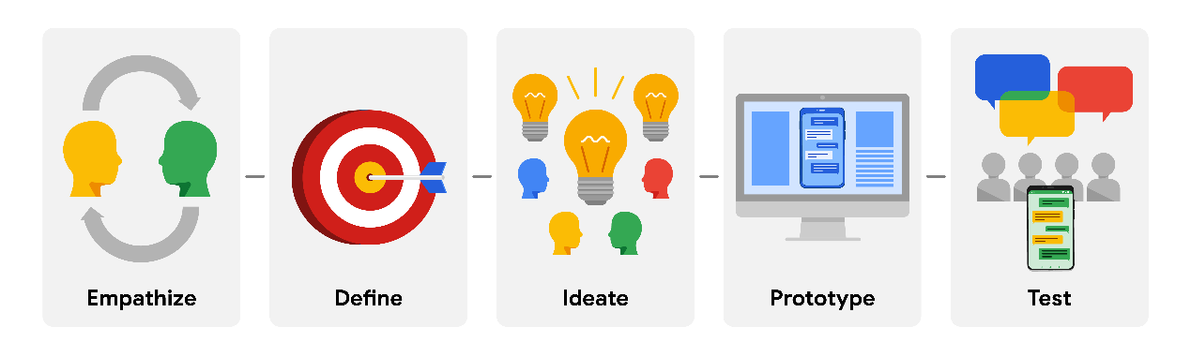

Though it may sound like a linear process, the Design Thinking framework should be iterative, which means that you’ll repeat certain phases as you refine your designs. For example, depending on the feedback you receive during testing, you might need to conduct additional research, brainstorm new ideas, or develop new prototypes.

Keep in mind that the Design Thinking framework as presented here is an idealized model for UX designers to follow, so you might see some variation in its implementation between different companies, teams, or projects.

## Empathize

During the **empathize** phase, your primary goal is to learn more about the user and their problems, wants, and needs, and the environment or context in which they’ll experience your design. The most important part of the empathize phase is to step away from your assumptions and guesses and let your research findings inform your decision-making in later design phases.

Your user research might include user surveys, interviews, and observation sessions, and you might also need to conduct some research on the competitors’ products to determine how your user frames competitors’ products as part of their daily life and daily problem-solving.

## Define

In the **define** phase, you’ll analyze your research findings from the empathize phase and determine which user problems are the most important ones to solve, and why. This will drive you toward a clear goal for the design of the product.

The most important outcome of this phase is a clear problem statement, which is a description of the user’s need that your designs will address. You might also develop a value proposition, which is a summary of why your user would or should use the product or service that you’re designing.

## Ideate

After you land on a user problem and establish why it’s an important one to solve, it’s time for the **ideate** phase. The goal of ideation is to come up with as many design solutions as possible—don’t settle for your first solution because the most obvious solution is not always the right one.

Ideation involves collaborative brainstorming with other members of your team to generate as many solutions as possible to a problem. This could include marketing, engineering, product management, or any other stakeholders for the product or service. During brainstorming sessions, you should explore all possible solutions. Don’t focus on whether something is a “good” or “bad” idea, just collect as many ideas as you can. The important thing here is to keep this process judgment-free.

After brainstorming, you’ll then analyze your potential solutions and start to make choices about which ones are the best options to pursue as prototypes. You might return to user or competitive research to help you narrow down your ideas, and you might also create user flows to illustrate how the user will interact with your solution.

## Prototype and Test

After you have an idea of how to solve the problem, you’re ready to enter the **prototype** phase, where your goal is to produce an early model of a product that demonstrates its functionality and can be used for testing. The **test** phase is critical to developing the right solution to address your user’s problem, and an organized approach to testing can help you create exceptional user experiences.

Prototyping and testing are interconnected, which means that you’ll test your designs at each stage of prototype development rather than waiting to test until after the working prototype is complete. If the design is too polished the first time you present it to users, you might not get as much feedback. Think about ways to include testing throughout the design process, so that you’re iterating your designs based on user feedback instead of other reasons.

For example, you might test the concepts behind your design by presenting users with a simple sketch, wireframe, or a sitemap. Taking what you learned, you might iterate on that design to a more detailed design on paper (known as a low-fidelity prototype) and conduct another round of user testing. At some point, you’ll iterate the design again into a working, interactive model using a software program (also known as a high-fidelity prototype) and test that as well. You might also consider testing more than one prototype at the same time to get feedback on multiple solutions, or testing the same prototype on multiple platforms, such as a laptop, tablet, and smartphone.

The goal of testing prototypes is to continue to refine the prototype as you gain insight into whether the design for your product or service is easy to use and solves the user’s problem. At some point, you’ll finalize a prototype, and then you’ll provide it to developers, who will then turn your design into a product.

## Summary

The Design Thinking framework is only one type of framework that UX designers use to organize their approach to designs, often based on the product they’re designing and the organization they’re working for. No matter which frameworks you use in your career, they all have a few core principles in common:

* Focus on the user.
* Create solutions that address the user’s problems.
* Collaborate with teammates across departments.
* Validate your designs.
* Iterate as needed to design the right user experience.